# COAL LAB 5

Q.1)

INCLUDE Irvine32.inc

.data

array byte 10 DUP (?)

.code

main PROC

mov edx, 1

mov ebx, 1

mov esi,offset array

mov [esi+1],eax

mov ecx, 5

L1:

mov [esi],edx

mov eax,[esi]

call writeint

call crlf

mov [esi+1],ebx

mov eax,[esi+1]

call writeint

call crlf

add edx,ebx

add ebx,edx

add esi,2

loop L1

exit

main ENDP

END main

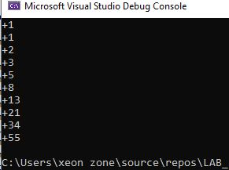

Q.2)

INCLUDE Irvine32.inc

.data

array dword 8,5,1,2,6

.code

main PROC

call BubbleSort

call delay

call crlf

mov esi,offset array

mov ecx,5

l:

mov eax,[esi]

call writeint

call crlf

add esi,4

loop l

exit

main ENDP

BubbleSort PROC

;mov esi,offset array

mov ecx, 4

L1:

mov esi,offset array

mov edx,ecx

mov eax,0

mov ebx,0

mov ecx, 4

L2:

mov eax,[esi]

cmp eax,[esi+4]

jl continue

mov ebx,[esi+4]

mov [esi+4],eax

mov [esi],ebx

continue:

call writeint

call crlf

add esi,4

loop L2

mov ecx,edx

loop L1

ret

BubbleSort endp

END main

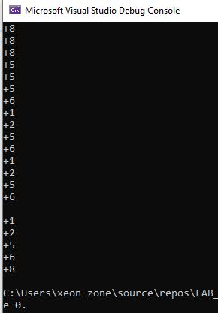

Q.3)

Include Irvine32.inc

.data

var byte "1",0

.code

Main PROC

mov ecx, 4

l1:

mov ebx,ecx

mov eax,5

sub eax,ebx

mov ecx, eax

l2:

mov edx,offset var

call writestring

loop l2

mov ecx,ebx

call crlf

loop l1

exit

Main ENDP

End Main

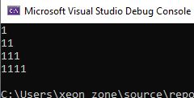

Include Irvine32.inc

.data

var byte "1",0

.code

Main PROC

mov ecx, 4

l1:

mov ebx,ecx

mov ecx, ebx

l2:

mov edx,offset var

call writestring

loop l2

mov ecx,ebx

call crlf

loop l1

exit

Main ENDP

End Main

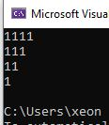

Include Irvine32.inc

.data

var dword ?

.code

Main PROC

mov ecx, 4

l1:

mov ebx,ecx

mov edx,4

sub edx,ecx

mov ecx, ebx

l2:

mov var,ebx

mov eax,5

mov ebx,ecx

add ebx,edx

sub eax,ebx

call writedec

mov ebx,var

loop l2

mov ecx,ebx

call crlf

loop l1

exit

Main ENDP

End Main

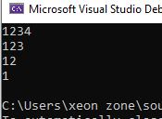

Include Irvine32.inc

.data

.code

Main PROC

mov ecx, 4

l1:

mov ebx,ecx

mov edx,4

sub edx,ecx

mov ecx, ebx

l2:

mov eax,ecx

add eax,edx

call writedec

loop l2

mov ecx,ebx

call crlf

loop l1

exit

Main ENDP

End Main

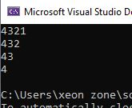

Q.4)

Include Irvine32.inc

.data

ID byte 5 DUP(?)

name byte 20 DUP(5 DUP(?))

birth byte 5 DUP(?)

annualsalary word 5 DUP(?)

var1 byte "ID: ",0

var2 byte "NAME",0

var3 byte "Birth year: ",0

var4 byte "Annual Salary: ",0

sum_as dword ?

.code

Main PROC

mov esi,0

mov ecx, 5

l1:

mov eax,0

mov edx,offset var1

call writestring

call readint

mov ID[esi],al

call crlf

mov edx,offset var2

mov ebx,dword ptr var2

call writestring

call readstring

mov dword ptr var2,ebx

call crlf

mov edx,offset var3

call writestring

call readint

mov birth[esi],al

call crlf

mov edx,offset var4

call writestring

call readint

mov annualsalary[esi],ax

add sum_as,eax

call crlf

inc esi

loop l1

mov eax,0

mov eax,sum_as

call writedec

exit

Main ENDP

End Main

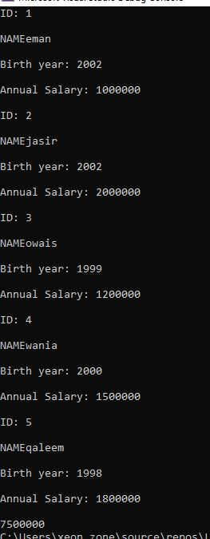

Q.5)

INCLUDE Irvine32.inc

.data

source byte "Hello World",0

target byte 12 DUP(?)

.code

main PROC

mov edx, 0

mov ebx, 0

mov esi,0

mov ecx, 12

L1:

mov dx,word ptr source[esi]

mov target[esi],dl

add esi,1

mov target[esi],dh

mov edx, 0

loop L1

mov edx,offset target

call writestring

call crlf

exit

main ENDP

END main

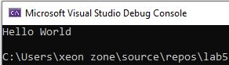

Q.6)

INCLUDE Irvine32.inc

.data

array byte 8,5,1,2,6

.code

main PROC

mov eax,0

mov esi,0

mov ecx,lengthof array

l:

mov al,array[esi]

call writeint

call crlf

add esi,1

loop l

call reverse

call crlf

mov eax,0

mov esi,0

mov ecx,lengthof array

l2:

mov al,array[esi]

call writeint

call crlf

add esi,1

loop l2

exit

main ENDP

reverse PROC

mov esi,0

mov eax,0

mov ebx,0

mov ecx,2

L1:

mov eax,0

mov ebx,0

mov edi,0

mov edi,ecx

add edi,2

mov bl,array[esi]

mov al,array[edi]

mov array[edi],bl

mov array[esi],al

add esi,1

loop L1

ret

reverse endp

END main

